PRESS RELEASE

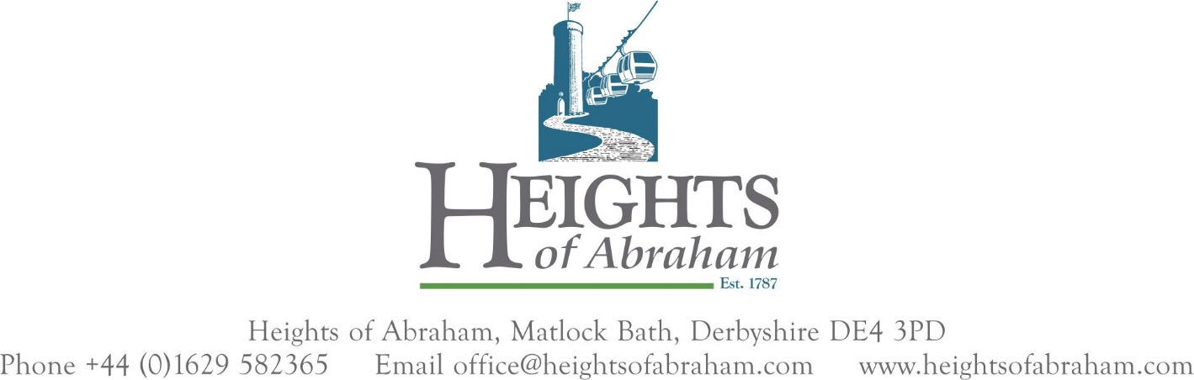

ISSUED 12 NOON TUESDAY 10TH MAY

**MAJOR NEW EXHIBITION TO OPEN AT THE HEIGHTS OF ABRAHAM THIS WEEKEND**

What do you wear on a day out in Derbyshire, and how has the way we dress changed over the centuries?

Saturday 14th May sees the opening of a major new exhibition that showcases exquisite reproductions of period costumes as worn by the Georgian, Regency, Victorian and Edwardian guests who visited the Heights of Abraham between 1787 and 1910.

Modern day guests will be able to walk back through time and come face to face with visitors of the past, whilst learning a little about the social and working conditions of their time. 14 life-sized mannequin figures, beautifully dressed in historically accurate clothing, populate the large exhibition housed in the refurbished Masson Pavilion. Animated picture frames alongside the figures reveal information about each time period.

The new exhibition, entitled “A Mirror on the Past”, is the third new attraction to open this year, supporting the hilltop park’s 2022 theme: celebrating visitors from the past. Earlier this year a sculpture trail of willow figures made by Cheshire based artist Caroline Gregson opened at the summit, and on weekdays until the end of June historically costumed actors can be found walking the serpentine paths through what was once known as a “savage garden”, a popular term for wild and exotic locations first coined by the Georgians in the late 18th Century.

The exhibition is housed in the Masson Pavilion, which has undergone a transformation into a dramatic theatrically lit space, with a new ramped entrance and canopied exit to allow for access for all visitors.

Rupert Pugh (Development Director, HOA) explains: *“Everyone knows us for our famous cable cars which were introduced in 1984, but we wanted to shine a spotlight on the fact that people have been coming here since 1787, making us Derbyshire’s oldest visitor attraction. Those early visitors came here to experience the serenity and beauty of the inspiring views from the summit. We started to wonder what they looked like, what life would have been like for them, and gradually an idea emerged for this new exhibition. We’re very pleased with the end result, which is something totally new and different for our guests to enjoy”.*

When it came to making and designing the costumes, the Heights turned to Arts University Bournemouth, which has an outstanding reputation for costume and wig making. Students from the BA (Hons) Costume and Performance Design and BA (Hons) Make-up for Media and Performance courses were commissioned to make the 14 costumes and the handmade wigs worn by many of the figures.

Sarah Magill, (Course Leader for the Arts University BA(Hons) Costume and BA(Hons) Performance Design and Film Costume courses) said *“This was such an exciting collaboration for our students and has provided them with real life experience of working on a commission. The project has challenged their research, design and making skills in addition to enhancing their knowledge of social and cultural history spanning two centuries. We are thrilled with the outcomes, which are professional and historically-accurate, and will be enjoyed by many visitors to the exhibition over the coming years.”*

The students were split into designers, supervisors and makers by the Arts University team, and worked alongside the Heights’ creative team to research accurate clothing and source rare fabrics for the costumes, which were then made in Bournemouth and transported to the Heights for installation.

The project was overseen by former Matlock Bath resident Steve Keeling of the creative interpretation company Monumental. The work on the Masson building and the exhibition was carried out by Derwent Treescapes working alongside the Heights’ in house team.

The exhibition will be open to the public from Saturday 14th May and is included in the cable car ticket price.

For more about the Heights of Abraham please go to [www.heightsofabraham.com](http://www.heightsofabraham.com)

To download photos of the Masson Pavilion and the Costume Exhibition go to [www.heightsofabraham.com/press](http://www.heightsofabraham.com/press)

Press Office contact: David A Thornton  
Head of Marketing  
Heights of Abraham  
Mobile: 07515 747658  
Email: [david@heightsofabraham.com](mailto:david@heightsofabraham.com)

Note to editors:   
  
Matthew Parris will officially launch the “A Mirror on the Past” exhibition at a private party on Friday 13th May. Photos will be available from Saturday 14th upon request.

